**Annex**

|  |  |  |
| --- | --- | --- |
| **Design Principles** | **Design Rules** | **The PHCaaS** |
| **User-Centricity** | * 1. The interface(s) and functionalities of the PHC system should be simple and intuitive to use. | The data processing and storage of the ecosystem are designed to deliver simple and intuitive interfaces for all its users. Representation of the information is also developed with reference to the existing International Standards. For instance, the "Treatment Plan" format is designed with respect to the guideline jointly developed by the NHS Foundation Trust and Care Coordination Association (*CCA and NHS Foundation Trust*, 2016) to ensure information visualisation with intuitive and straightforward interfaces. The system is open to accommodating any standard guideline regarding interface design and information visualisation (subject to availability). |
| * 1. The system's notification interface(s) should visually convey the minimum essential information to the extent possible. | The ecosystem may distribute the following types of notifications to its users:   * System update * Security update * Treatment plan update * Appointment schedules (Confirmed/Cancelled) * Breach information.   The notification feature of the ecosystem may follow the generic minimum essential information practice by default. However, the ecosystem is open to adopting any standard for minimum essential information¨ visualisation (subject to availability). |
| * 1. The PHC system should modify the user interface(s) according to context (e.g., user persona). | The ¨Health Profile¨ feature of the ecosystem can enable interface modification based on the user's physiological data, supported by the patched biosensor device. |
| * 1. The system's user interface(s) and functionalities should ensure user needs (e.g., clinical, emotional, and practical). | The ecosystem is capable of addressing the following user needs related to PHC services:   |  |  |  |  | | --- | --- | --- | --- | | User Type | Clinical | Practical | Emotional | | Patient | EHR/EMR | Treatment Plan,  Digital Twin | Consultations, Communications, Feedback | | Health Practitioner | EHR/EMR, Genomic Profile, Digital Twin | Clinical Taxonomy,  Treatment Plan | xxxx | | PHC Provider | Data Analytics | System Status and Security Dashboard | xxxx | | Regulator/Policy Makers/Payor | Data Analytics | xxxx | xxxx | | Technology Vendor | xxxx | System Status and Security Dashboard | xxxx | |
| * 1. The system's user interface(s) and functionalities should be compatible with various devices and networks. | The ecosystem is designed to include both the conventional (existing) and emerging information technologies in Digital Healthcare (Zahid et al., 2021) to ensure compatibility with different devices and networks. |
| * 1. The system should include an appropriate mechanism(s) to acquire user feedback and apply that knowledge to further system refinement. | The ecosystem may include the "Feedback Manager¨ feature to collect user (patient, health practitioner) experience and ratings and use them in further system refinement. |
| **Privacy and Security** | * 1. The PHC system should demonstrate good use of strong authentication protocols for all types of users. | The ecosystem may incorporate the conventional protocol mechanism for user authentication and access. In addition, the ecosystem may include ¨Healthchain Network¨, a private Blockchain Network for identity and access management. The immutability and decentralisation characteristics of the ¨Healthchain Network¨ can be potential to ensure a ¨strong¨ user authentication and access management for the system. |
| * 1. If the PHC system needs to patch additional hardware for care delivery, the hardware must comply with all the medical cybersecurity requirements. | The ecosystem recommends and supports patching medical devices certified by international standards (e.g., CE, TM). The patching of medical devices is subject to regulatory guidelines (if available). The ecosystem is open to adopting any ¨medical device attachment¨ requirement imposed by the regulations. |
| * 1. The system must be able to anonymise personally identifiable information (PII) from the data collected in accordance with applicable healthcare data privacy and security regulations. | The ecosystem strictly restricts access to PII to limited users only by design. Conventionally, the ecosystem stores all the collected and processed PII in a data repository in an encrypted format. The ecosystem, by default, may allow the de-anonymisation of PII by the authorised/designated users only. In addition, all PII of the users can be stored in ¨Healthchain Network¨, a private blockchain consortium in an encrypted format. It may ensure an additional data privacy and security layer for PII as the network maintains an immutable access log for all its users. By design, the ecosystem is open to adopting any PII guideline imposed by the regulatory (subject to availability). |
| * 1. The system should comply with the "privacy by design" requirement as a latent need in each step of its development and operational activities (log-data minimisation, pseudonymisation). | The ecosystem complies with ¨privacy by design, ¨ the requirements guided by GDPR (2018) and can operate in compliance with the organisational and technical requirements as per the GDPR guideline. The system is capable of operating with privacy in each step of its development and activities (log-data minimisation, pseudonymisation). Nevertheless, the ecosystem is open to adopting any internationally recognised ¨privacy by design¨ guideline (subject to availability). |
| * 1. The system should comply with the "privacy by default" requirement, where a minimum (acceptable) level of protection is assured. | The ecosystem potentially complies with the least privacy-invasive requirements, as guided by the GDPR (2018). By default, the system can ensure a minimum level of protection by integrating the conventional security mechanism and emerging blockchain technology. Furthermore, the ecosystem is open to adopting any other internationally recognised ¨privacy by default¨ guideline (subject to availability). |
| * 1. The system should include appropriate notification mechanism(s) (e.g., email, SMS, in-app notification) to provide security updates, data protection and compliance information to its users. | The ecosystem may incorporate a real-time "Notification" mechanism to share updates (e.g., system update, security update, appointment update, treatment plan update) among the users. In addition, the ecosystem can also incorporate external notification management solutions supported and operated by any third party (subject to regulatory/availability). |
| * 1. The system should immediately notify users affected by any data breach upon discovery. The notification should contain information about the incident, it's timing, a description of the health information compromised, and the applied action(s) to control or minimise the impact. | The ecosystem may notify the affected user through their preferred channel (email, SMS) and the following information: breach info, time and date, and description or compromised health information. An example of action taken to address the breach is "We are currently investigating the issue. Your ID is temporarily blocked. You will be informed with the update (SMS/email) when the issue is resolved".  •Breach Info  •Time and Date  •Description of the health information compromised.  •Action was taken: (e.g., "We are currently investigating the issue. Your ID is temporarily blocked. You will be informed with the update (SMS/email) when the issue is resolved"). |
| **Traceability** | * 1. The system should include its users' digital tracking and decision-making feature(s). | The ecosystem may include a "Healthchain Network" (Private Blockchain Consortium) that is capable of assuring an "immutable" digital tracking for all the information collected, processed, and stored by the system. The ecosystem is also able to compliment all users' decision-making (e.g., patient-consultation appointment scheduling, health practitioner-treatment plan, consultation approval, platform provider-data analytics dashboard, system security, and status dashboard). |
| * 1. The system's digital tracking feature(s) should be able to generate a unique identity for each of its transaction logs. | The ecosystem may store all the processed information (e.g., appointments, treatment plans) in a private blockchain consortium called "Healthchain Network". The designed network may maintain a "decentralised and immutable" transaction log for all the transactions made in the network. It may also ensure a unique identity for each transaction the system makes. |
| **Transparency** | * 1. The system should include an appropriate mechanism(s) to reveal the data privacy and security, access, control, ownership, sovereignty, data sharing, storage, and associated risks to its users. | The ecosystem may include standard terms and conditions that explicitly provide information regarding data privacy and security, access, control, ownership, sovereignty, data sharing, storage, and associated risks to its users. However, the practice of such policies is subject to regulation/availability. Therefore, the ecosystem is open to accommodating any policy/guideline practised by the regulatory (subject to availability). |
| * 1. The system should disclose patients' information (including content) with patient consent or legal power of attorney. | The ecosystem is capable of accommodating such exceptions in compliance with the regulatory guideline (subject to availability). |
| * 1. The system should be able to execute authorised business processes to ensure compliant data processing with design specifications. | Data processing of the ecosystem is designed in compliance with the guiding principles provided by different international standard organisations such as GDPR (2018). Therefore, it fully represents the design specification of the system. |
| **Accountability** | * 1. The system must include a Computer Security Incident Response Team (CSIRT) with specific roles and responsibilities to ensure system security and accountability among the stakeholders. | The ecosystem may compliment such involvement of human resources by providing different dashboards (System Security, System Status, Healthchain Explorer). |
| * 1. If applicable, the system may include a "Real-Time Threat Sharing" mechanism to create and share IOCs (Indicators of Compromise) among the stakeholders. | The ecosystem may adopt a real-time Threat Sharing protocol in communications among the stakeholders regarding cyber-incident, information breaches, and confidential data sharing. Furthermore, the ecosystem may adopt TLP in labelling the sensitivity of the information exchanged among the stakeholders. |
| **Auditability** | * 1. The system should include a 2-stage analytics approach to its collected data (e.g., modelling of testing). | All the dashboards of the ecosystem (Data Analytics, System Status, and System Security) may incorporate a 2-stage analytics approach to its collected data to determine the predictive, prescriptive, and perspective analytics and visualise the system insights. |
| * 1. The system provider should include a Privacy Impact Assessment (PIA) system to evaluate the data privacy measure(s) applied by the system's servers, data, clients, and other relevant. | The ecosystem may complement the inclusion of PIA as part of the system status evaluation. |
| **Interoperability** | * 1. The system should adapt commonly available interoperability standards to comply with local regulations, enabling real-time data sharing and common understanding within the healthcare ecosystem. | The ecosystem is open to any interoperability standard for adaption. However, the selection of Interoperability standards is subject to availability/regulations. |
| * 1. The system should be able to identify users with a degree of certainty. | The ecosystem may include "Healthchain Network", a private blockchain consortium that can record user identity in a "decentralised and immutable" log. The log may ensure a higher degree of certainty in user identification. |
| * 1. The system must ensure a minimum standard of data quality with sufficiency. | The ecosystem is designed in principle with the minimum data standard, quality and sufficiency, as advised by the internationally recognised guidelines (*GDHP*, 2019; *Principles for Digital Development Working Group*, 2016). Nevertheless, the ecosystem is open to adopting any standard policy on minimum data standards, quality and sufficiency practised by the regulatory (subject to availability). |
| **Scalability** | * 1. The system's design and development should be iteratively refined and complemented by a continuous design review process(es). | The ecosystem's design has undergone numerous iteration cycles and complies with the ¨continuous design review¨ requirement for further refinement. |
| * 1. The system should comprise an impact evaluation methodology to evaluate its performance for scalability and associated risks of non-performance. | The ecosystem may provide multiple dashboards (system status, system security) to visualise the system performance and health status and evaluate the ecosystem for upscale. |
| * 1. In incorporating new technological innovation(s), the PHC system should comply with legal co-standards and technical requirements. | The ecosystem is open to adopting legal standards and technical requirements for incorporating new technological innovation(s). |
| **Sustainability** | * 1. The system's sustainability initiative(s) must be developed by involving patients, providers, and regulators (stakeholders). | The ecosystem is designed and refined through collaborations involving experts from different healthcare stakeholders. |
| * 1. The system should provide a dashboard that reports the balance of enabling and constraining affordances. | The ecosystem may provide three comprehensive dashboards (Data Analytics, System Status, and System Security) that report on the needed actions for system performance, scale, and sustainability by the Service Provider, Policy Makers, Regulator, Payor, and Technology Vendor. |
| **Table A: Design Attributes of PHCaaS - Principles and Rules.** | | |

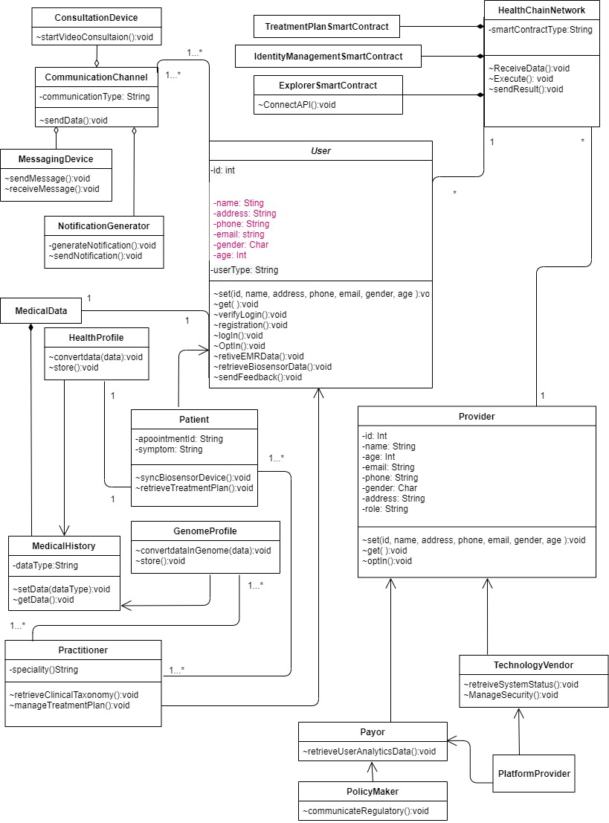

**Figure A: EHR Class Diagram in PHC Ecosystem.**

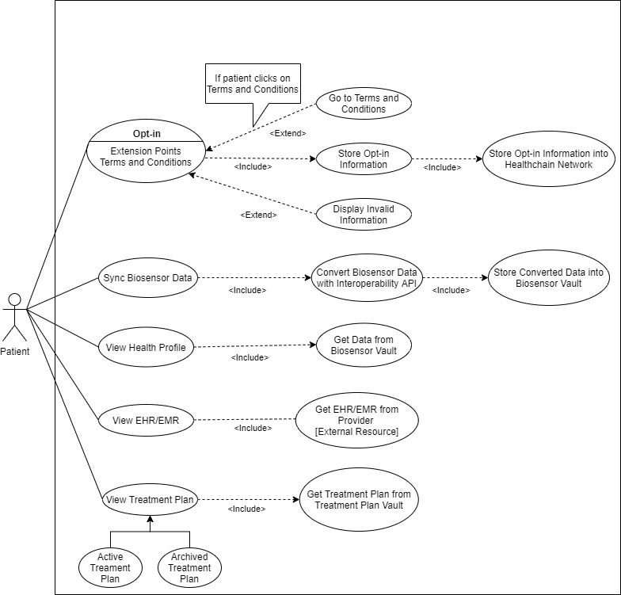

**Figure B: Use Case Diagram – WV of Patients.**

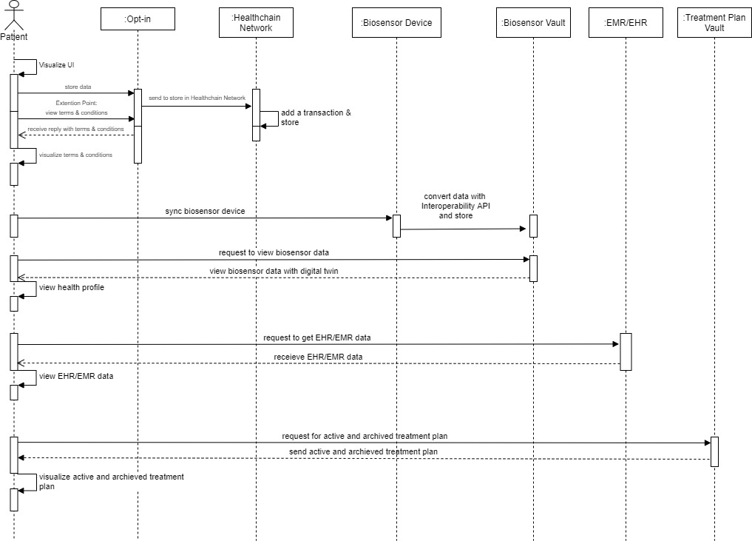

##### **Figure C: Sequence Diagram of Patient Consultation.**

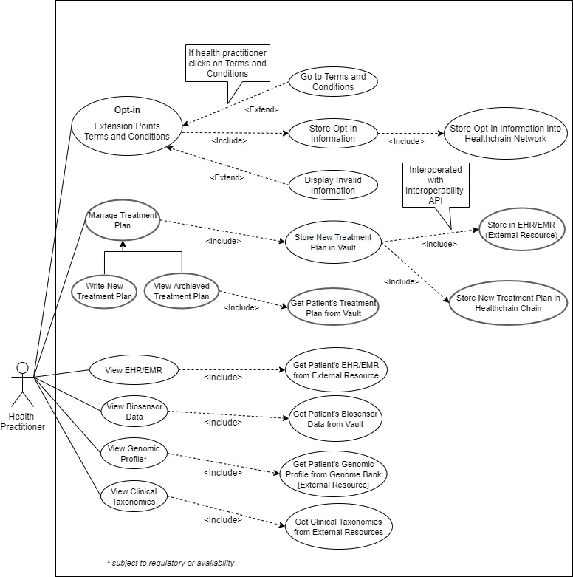

**Figure D: Use Case Diagram – WV of Health Practitioner.**

##### **Figure E: Sequence Diagram – Health Practitioner.**

**Figure F: Use Case Diagram - PHC Service Provider, Policy Maker, Regulator, Payor, and Technology Vendor.**

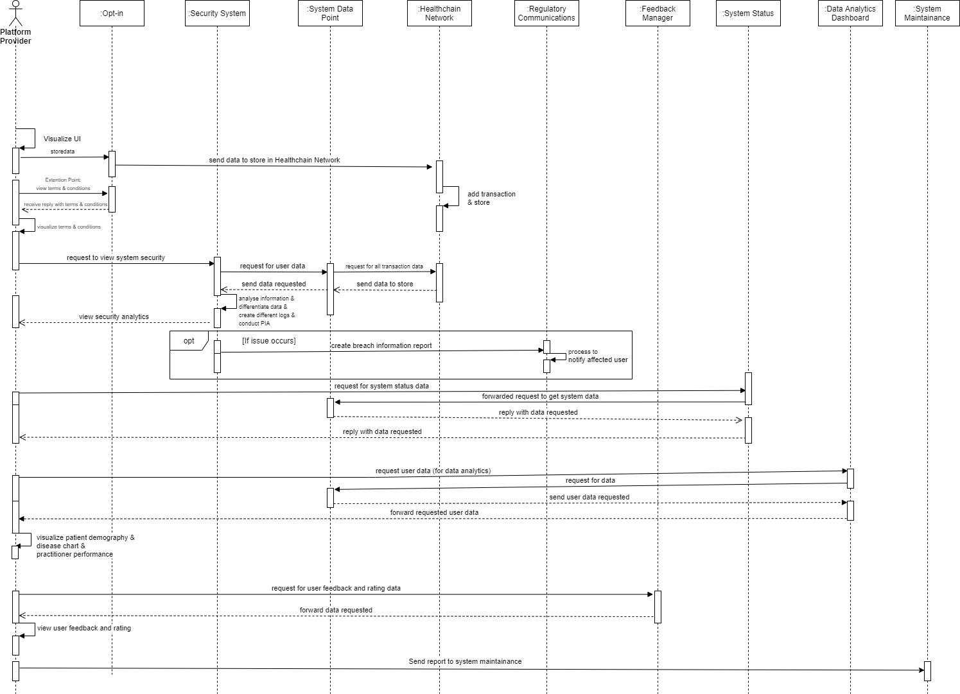

##### **Figure G: Sequence Diagram – PHC Service Provider.**

|  |  |  |  |  |  |  |
| --- | --- | --- | --- | --- | --- | --- |
| Sl No. | Comments/Suggestions for Improvement | Economically Viable? | Socially Desirable? | Technologically Feasible? | Include/Exclude | Notes and Memos |
|  | I would suggest to **take the views of industry partners** who may have different perspectives on the developed prototype. | Yes | Yes | Yes | Exclude | Collaboration for health system design and development is economically viable, technologically feasible, and socially desirable in today's data-driven culture (Adams, 2010; Lo Presti et al., 2019). The demonstrated artefact and sub-artefacts of the PHC ecosystem are developed based on system design principles, rules, and emerging information and communication technologies extensively discussed in recent studies and regulatory guidelines. In addition, the ecosystem incorporates different healthcare stakeholders' viewpoints in design refinement for improvement (DRI and DVW). |
|  | I would highly recommend **creating a smartphone-based apps** for the artefacts regardless of the patient/user.  The system must be **compatible with any device and network**.  I would like to see **the information sharing mobility** from user point of view regardless the location, country, service provider or biosensor devices.  Try to create a **robust API** by chasing the updated technology is my suggestions. | Yes | Yes | Yes | Include | Ubiquitous access and device compatibility in the current data-centric healthcare setting is highly desirable, technologically feasible, and economically viable (Crotty & Slack, 2016; Eliasen et al., 2018; New Zealand Ministry of Health, 2016). The demonstrated artefact and sub-artefacts of the PHC ecosystem support ubiquitous access to different devices and technology platforms by incorporating an interoperability mechanism. However, ubiquitous access and device compatibility are subject to different factors (healthcare service providers, regulatory guidelines, etc.). Nevertheless, upon real-world implementation, the ecosystem can be made accessible with a smartphone-based app (robust API). |
|  | **Provide extensive training** before start using that apps or web-portal system. | Yes | Yes | Yes | Include | Necessary end-user training (e.g., patient, health practitioner, service provider) is economically viable, technologically feasible, and socially desirable in today's data-driven healthcare culture (Labrique et al., 2018) and can be conducted with real-world implementation of the designed ecosystem. |
|  | I would suggest **making such a product affordable enough** to be accessible by users of developing nations despite the expenses that goes into developing such a system. | Yes | Yes | Yes | Exclude | An affordable digital health ecosystem is highly desirable, technologically feasible, and economically viable in today's data-driven society (Botti & Monda, 2020). The demonstrated artefact and sub-artefacts of the ecosystem are open to customisation in accordance with budgetary allocation, regional settings, and regulatory compliance. |
|  | Make the **UI, UX** of the actual product **simple**, thinking of mass population.  **User friendly, simple and easy to access** | Yes | Yes | Yes | Exclude | Simple, user-friendly, intuitive UI ad UX is socially desirable, technologically feasible, and economically viable in today's digital healthcare applications (Nath & Sharp, 2015; *Digital Health: Heaven or Hell?*, 2016; Labrique et al., 2018). The demonstrated artefact and sub-artefacts of the ecosystem are developed based on the system design rule for simple and intuitive interface(s) and functionalities. According to the existing International Standards, the representation of the information in user interfaces and functions in real-world systems are developed. The proposed system incorporates all the required technologies (Artificial Intelligence, Big data analytics) to support the addressed need by the healthcare actors. Therefore, the demonstrated artefact and sub-artefacts of the PHC ecosystem are confident to ensure a simple and intuitive user interface/experience in the real- world system environment. |
|  | User should get all the **healthcare related facilities** from this **at one finger tip** with the service charges. | No | Yes | Yes | Exclude | Achieving "All in one" services in an ecosystem is an ongoing challenge due to various constraints such as literacy, skilled workforce shortage, technological infrastructure, and regulatory enforcements in current healthcare settings. This may be socially desirable and technologically feasible but not economically viable (Hogg, 2019). However, the developed ecosystem offers the following services in alignment with the desired "All in one" services for its users:  **Patient:** *Video Consultation, Messaging, Appointment, Feedback, Notification, Health Profile (Digital Twin), Treatment Plan, EMR/EHR.*  **Health Practitioner:** *Video Consultation, Messaging, Appointment, Feedback, Notification, Health Profile (Digital Twin), Treatment Plan, EMR/EHR, Genomic Profile, Clinical Taxonomy.*  **PHC Provider:** *HealthChain Network, Data Analytics Dashboard (Disease Chart, Patient Demography, Health Practitioner Performance Matrix), System Status Dashboard, System Security Dashboard.*  **Regulator/Policy Makers/Payor:** *Data Analytics Dashboard.*  **Technology Vendor:** *System Status Dashboard, System Security Dashboard.* |
|  | The whole thing has to be sorted out by **understanding** his **needs**, communicating with him and his satisfaction.  it must **fulfil the patient's need**.  Should **address patients' healthcare needs**. | Yes | Yes | Yes | Exclude | Detailed understanding of needs is socially desirable, technologically feasible, and economically viable in today's digital health culture (Cresswell et al., 2013; UK Department of Health & Social Care, 2019; Principles for Digital Development Working Group, 2016e; Imison et al., 2016; Digital Health: Heaven or Hell?, 2016; Stickdorn & Schneider, 2012). The demonstrated artefact and sub-artefacts of the PHC ecosystem are developed based on the design rule concerning "user need". The ecosystem is capable of addressing the clinical, practical, and emotional needs of users. |
|  | Less typing feature | Yes | Yes | Yes | Exclude | The ecosystem is developed to ensure "less typing effort" for all its users as its socially desirable, technologically feasible, and economically viable in today's digital health culture. Therefore, the system only includes typing for the following system's features for the users:  ***Patient:*** Messaging, Feedback, Appointment (Special Notes).  ***Health Practitioner:*** Messaging, Feedback, Appointment (Special instruction to the patient), Treatment Plan.  ***PHC Provider:*** *Regulatory Communications****,*** *System Query****.***    ***Regulator/Policy Maker/Payor/Technology Vendor:*** *System Query (relevant to access privilege), Communications.* |
|  | **Relentless service delivery**  It should be **less time consuming and fast report delivery** so that doctors can do fast diagnosis. | Yes | Yes | Yes | Exclude | Real-time, seamless digital health service is socially desirable, technologically feasible, and economically viable in the current healthcare context (Chen et al., 2022). However, the system performance (service) depends on different vital factors (e.g., implementation setting, maintenance, operation). Therefore, the ecosystem is designed to be compatible with operating in-house and cloud settings, providing the needed flexibility to the PHC providers. |
|  | Accurate patient **data collection.** | Yes | Yes | Yes | Exclude | Data accuracy in the current healthcare setting is socially desirable, technologically feasible, and economically viable (Hogan & Wagner, 1997). The designed ecosystem incorporates appropriate technologies (Artificial intelligence, Big Data analytics) to process, store, access, and visualise data with higher accuracy to its users. However, the accuracy of data collected from external resources (Genomic Profile, EMR/EHR) is subject to providers' system efficacy. |
|  | **Patient should have access to everything** practitioners and platform providers have access to, even when not relevant to their condition.  Alter information provided to be equal rather than top down; i.e., **let the patient see everything they want/need** to; i.e., analytics. | No | Yes | Yes | Exclude | Unrestricted patient access to his/her health data is socially desirable and technologically feasible but not economically viable (Chan et al., 2013; Mandl & Kohane, 2016). The ecosystem allows patients to access data related to his/her healthcare. However, the system does not allow patients Access to their genomic profile as a) it requires genomic literacy (which is uncommon in patient demography), and b) it includes an additional cost (for data exchange, maintenance, and visualisation). |
|  | The system's **notification interface(s) should be telescopic**; expanding to more information if the patient desires it.  **More details should be given on the notification system requirements** and when/how it gets patient information. | No | Yes | Yes | Exclude | Telescopic notification is technologically feasible and socially desirable (Robotham et al., 2016), but may not be economically viable as it includes data management, distribution, and storage-related cost for the service provider. The notification feature of the ecosystem is designed in alignment with the design rule regarding notification, based on the literature extant, which suggests the broadcast of ¨minimum essential information¨ for the patients. However, the patient can inquire for more information regarding any broadcasted notification by directly contacting the PHC service provider via conventional communication channels (e.g., email, phone). |
|  | Allow the user to **modify what they see from their side**. | Yes | Yes | Yes | Exclude | Interface modification is socially desirable, technologically feasible, and economically viable in the current digital healthcare context (Cheon et al., 2016; *WHO*, 2019). The designed ecosystem allows such desired interface modification. It is capable of supporting changes in information visualisation patterns on the user interface. |
|  | further concern is necessary for data protection. | No | Yes | Yes | Exclude | The implication of the data protection mechanism is socially desirable, technologically feasible, and economically viable in the current digital healthcare context (McGraw & Mandl, 2021; Rockwern et al., 2021). Addressing the exponential growth of cyberattacks (*GDHP*, 2019b), the designed ecosystem incorporates Blockchain in addition to conventional security mechanisms, which maintains an immutable audit trail for every data storage and access in the system. Therefore, integrating more technological solutions to monitor malpractice (for data protection) in the system is not practical and cost-effective (Ponemon, 2016). |
|  | **Notification** of changes to CSIRT should be included from an external source (for redundancy) | Yes | Yes | Yes | Include | Circulation of change notification among healthcare entities is socially desirable, technologically feasible, and economically viable (Ruefle et al., 2013;  *GDHP*, 2019). Therefore, the designed ecosystem maintains a real-time Threat Sharing protocol in communications (including the notification) among the stakeholders (external resources) regarding cyber-incident, information breaches, and confidential data sharing. |
|  | More **governance safeguards and accountability** is needed for user/patient centricity. | No | Yes | Yes | Exclude | Health data governance with accountability is technologically feasible and socially viable in the current healthcare setting (Germann & Jasper, 2020; Tiffin et al., 2019). Addressing this, the designed ecosystem incorporates Blockchain in addition to conventional security and accountability mechanisms (database). Blockchain ensures an immutable audit trail for every data storage and access in the system. This technological integration ensures the system's state-of-the-art governance, safeguarding, and accountability. Therefore, integrating more technological solutions for governance safeguards and accountability in the system is not practical and cost-effective. |
|  | **use timestamp** for all activities happens within the system will increase transparency.  The system should have **digital tracking feature**. | Yes | Yes | Yes | Exclude | Using timestamps and digital tracking to ensure system transparency is technologically feasible, socially desirable, and economically viable (*TEFCA*, 2018; *WHO*, 2018; Agarwal et al., 2018; Frøen et al., 2016). The designed ecosystem incorporates timestamps (immutable) for all the operations executed through the system and complements digital tracking. |
|  | **User controlled data usage**.  Patient data should be made **accessible** with patient **consent**.  The **patients data** must be treated just like a patients **non-transferable** property. It cant be be accessed, shared or used without the  **patients consent**.  The Doctors without the **patients consent** cannot in any way **except a life saving situation** of the patient will be able to access the data  As I **don't want my treatment seeing by others** at a open place. This should be between patient and doctor, sometimes the diagnostic technicians.  The ecosystem should **seek user consent** before making any system security improvements for the system. | Yes | Yes | Yes | Exclude | Patient-controlled health data usage is technologically feasible, economically viable, and socially desirable (Chan et al., 2013; Mandl & Kohane, 2016). The ecosystem is designed to address such needs. The ecosystem utilises and exchanges all types of user data with consent by default during registration. The system also seeks time-to-time consent for security or application update(s). This ensures informed and controlled data usage in principle. The ecosystem allows system access by the patient nominated user in case of his/her inability (nominee information collected at patient registration). By design, the ecosystem ensures the privacy needs of users with multiple data privacy and security implementations in the ecosystem (Multi-factor authentication for user access verification and Healthchain Network for data security and storage). However, the proposed ecosystem is not developed to facilitate emergencies and advise conventional procedures in a medical emergency. |
|  | **Two steps verification and the process of converting information or data into a code**, especially to prevent unauthorised access must be ensured.  I would suggest including an extra layer of security such as '**two-factor authentication**' or '**2-step verification**' to get an access to the portal for all the parties  I'd suggest **adding another layer of security** in the interface between external systems and the designed system. | Yes | Yes | Yes | Include | Two Factor Authentication (2FA) is technologically feasible, economically viable, and socially desirable in current digital health applications (Das et al., 2019). the ecosystem is open to adopting any type of 2FA combination. However, the adoption of 2FA is subject to the service provider and regulatory guidelines. The ecosystem intends to incorporate JSON Web Token (JWT) for user authentication while exchanging data with the external system resource(s) upon implementation. |
|  | **patients's got more conscious thinking about whether we'll record that or not**, who'll be with the doctor, **how the data will be kept secured** etc. So, the security system must be strong. | Yes | Yes | Yes | Include | Point-to-point (p2p) encryption in health-related communications is technologically feasible, economically viable, and socially desirable in the current digital health context (Elhai & Frueh, 2016). Therefore, the designed ecosystem intends to employ a P2P (Point to Point) encryption mechanism for all messaging and video communications between the patients and health practitioners upon implementation. |
|  | The **security** of the data **storage and access** to it must be ensured.  Should ensure **data privacy** for its users.  The data security should be top notched for the privacy of patients.  Privacy by default should be assured.  The security control of Blockchain should include identity and access management, secure communication, smart contract security, transaction endorsement etc. | Yes | Yes | Yes | Include | Robust data privacy and security, storage and access mechanism(s) are technologically feasible, economically viable, and socially desirable in the current digital health context (el Ouazzani et al., 2020). The designed ecosystem restricts the sharing of Personally Identifiable Information (PII) only to eligible system users (e.g., health practitioner, payor, provider) to ensure data privacy. Moreover, in addition to the conventional security technique, the designed ecosystem incorporates Blockchain for access control, identity verification and management, security and data storage. This combination ensures state of the art ¨privacy¨ by default for the ecosystem and its users. |
|  | Blockchain **aspects and enhanced security should be implemented** at all points of ingress and egress of data and credentials. | No | Yes | Yes | Exclude | A robust data privacy and security mechanism(s) is technologically feasible, economically viable, and socially desirable in the current digital health context (el Ouazzani et al., 2020). The PHC ecosystem is designed to address such needs. However, the integration of Blockchain in all points of ingress and egress of data and credentials is not practical and cost-effective (Abu-elezz et al., 2020; El-Gazzar & Stendal, 2020; Mackey et al., 2019; Park et al., 2019; Rückeshäuser, 2017). Therefore, the designed ecosystem incorporates Blockchain for access control, identity verification and management, security and data storage. |
|  | I'd like to see **more systems in place to monitor doctors periodically** to ensure such cases are detected and dealt with swiftly | Yes | Yes | Yes | Exclude | Seamless performance monitoring in digital healthcare services is a legitimate desire of the service provider and patients. It is technologically feasible and economically viable in a digital health setting (Imison et al., 2016). The designed ecosystem already accommodates health practitioners' performance analysis features. In addition, the blockchain network adopted for the system ensures state-of-the-art monitoring through its immutable audit trail. Therefore, including an additional monitoring system is not practical and cost-effective. |
|  | I would recommend using **common interfaces** for all the users. For example, it can be a software such as REDCap or something like that.  The ecosystem should **adopt an internationally recognised interoperability standard**. | Yes | Yes | Yes | Include | Application of common, internationally recognised interoperability standards is technologically feasible, economically viable, and socially desirable (*GDHP*, 2019a; *European Commission*, 2014; Liaw et al., 2014; McMorrow, 2014). The designed ecosystem is open to accommodate any available interoperability standard. However, the adoption of interoperability standards is subject to regulatory guidelines. |
|  | perhaps adding support for **other standards in addition to FHIR** could help integrate into other systems better. | No | Yes | Yes | Exclude | Integrating multiple interoperability standards is technologically feasible and socially desirable but not economically viable (Reisman, 2017). Multiple interoperability standards in a single ecosystem is not practical and cost-effective. |
|  | **Should maintain minimum data standard**. | Yes | Yes | Yes | Exclude | Maintenance of minimum data standards is socially desirable, technologically feasible, and economically viable (*GDHP*, 2019a; *Principles for Digital Development Working Group,* 2016b). According to the integrated interoperability standard, the ecosystem is open to maintaining the minimum data standard (subject to regulations). However, the operation and maintenance of minimum data standards is subject to regulatory guideline. |
|  | As far I'm getting **quality calling service and adequate patient data** I'm fine. No other comment on interoperability.  As for Doctors we need the **system just to run smoothly** | Yes | Yes | Yes | Exclude | Seamless digital health service is economically viable, socially desirable, and technologically feasible (Imison et al., 2016). According to the regulatory guideline (operating region), the ecosystem is open to facilitating the exchange of adequate patient data. The designed ecosystem is capable of ensuring seamless information exchange while in real-world operation. However, interference in data exchange in a real-world context occurs due to external factors (e.g., cloud provider, bandwidth provider) beyond the ecosystem's control. |
|  | Data Flow should be very fluent to make it better. | Yes | Yes | Yes | Exclude | Flawless data exchange among the healthcare entities and related actors is socially desirable, technologically feasible and economically viable ("Orion Health," 2020). The designed ecosystem incorporates Blockchain, which maintains an immutable audit trail for the system and ensures fluent data exchange with traceability and transparency. |
|  | It should have the flexibility of changing time to time as technology is being updated regularly rather than be stuck with a certain technology. | Yes | Yes | Yes | Include | Regular updates and upgrades of digital health services are technologically feasible, economically viable, and socially desirable. The designed ecosystem supports such a time-to-time need and intends to be updated/upgraded on a routine basis upon real-world implementation. |
|  | In user-centricity the designed artefact should be more robust and flexible. | Yes | Yes | Yes | Exclude | User centricity in digital health services is socially desirable, technologically feasible, and economically viable (Singh et al., 2016). The suggestion is unclear. However, as the literature recommends, the developed ecosystem's patient-centricity ensures robustness and flexibility. |
|  | I recommend the use of a micro service to make the system more secure. | Yes | Yes | Yes | Exclude | Scalable digital health service is economically viable, technologically feasible, and socially desirable. However, the suggestion is vendor specific. Therefore, it has not been considered for adoption into artefact and sub-artefacts refinement. The ecosystem is designed to keep scalability in view, and its potential can be more visible in a real-world implementation. |
|  | Patient should be able to communicate with the doctor easily through the system. | Yes | Yes | Yes | Exclude | Real-time communication in digital health services is socially desirable, economically viable, and socially desirable. The designed ecosystem accommodates such features to facilitate flexible communications between the health practitioner and patient. |
| Table B: Coding Scheme of Design Refinement Interviews (DRI). | | | | | | |



**Figure H: Word Cloud of Design Refinement Interviews (Generated by NVivo).**

**Figure I: Cluster Analysis of Responses from PHC Actors (Generated by NVivo).**

**Figure J: Text Analytics of Responses from PHC Actors (Generated by NVivo).**